**Angling Award Application**

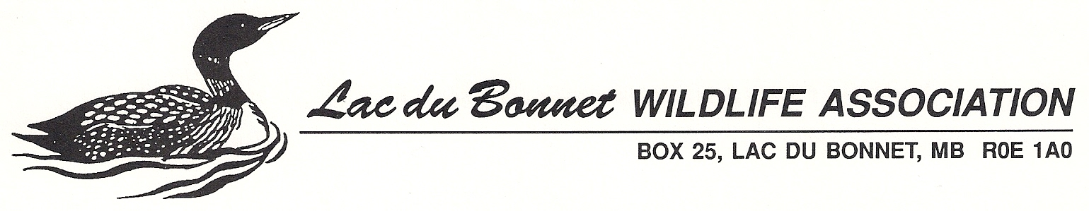

(Please print clearly or complete on computer and save as a Word or pdf document)

Name of Angler ...........................................................................................................

Parent or Guardian Name if Youth Angler: .................................................................

Birth Date: Month ..................... Day................. Year .................

Address.......................................................................................

City or town........................................................... Postal Code: .........................................................

Phone: (Home)....................... (Cell)............................. email address.................................................

Species of fish............................................................. Little Loon Angling Club

Length in cm............................. (not required to be Master Angler sized)

Date caught: Month ................. Day................. Year .................... Released

Name of Water where caught........................................................

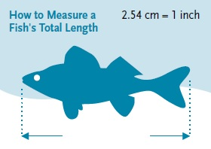

As per the Manitoba Angler’s Guide, total fish length is measured from the most anterior part of the head to the most posterior part of the tail laid flat (i.e. not pinched). The total length of the fish will be measured to the longest half centimeter.  (i.e. A fish measuring 25.0 to 25.4 cm will be recorded as 25.0 cm. A fish measuring 25.9 cm will be entered as 25.5 cm.)

I certify that this fish was caught in accordance to Manitoba Angling Regulations and that I was a member in good standing of the Lac du Bonnet Wildlife Association when this fish was caught.

Signature of Angler (or Parent/Guardian if Youth Angler) ................................................................

**Do not forget to include your pictures!**

**Be sure you receive an entry confirmation number from the Angling Award Coordinator, LdB Wildlife Association.**

Submit application to:

Dennis McGuffin, Angling Director

Box 25, Lac du Bonnet, MB R0E 1A0

Email: LDBWAangling@gmail.com Phone 204-899-0298

*v.2024-11-26*